***PROJECT DOCUMENTATION.***

**ACKNOLOWDGEMENT REPORT**

We like to thank the following people for their support and encouragement.

1. MR CHRISTIAN OUR FACULTY.

2 .MR CYRIL ODOGUN OUR PROJECT COUNCELLOR.

3. APTECH COMPUTER EDUCATION IKEJA.

4. DANIEL ALOIYE ETSE-OGHENA (GROUP LEADER).

5. NWOSU STANLEY CHUKA (GROUP MEMBER).

6. OYEWOLE GBOLAHAN EMMANUEL (GROUP MEMBER)

7. OKEWUSI OREOLUWA DAVID (GROUP MEMBER)

8. OUR DEPARTMENT (SOFTWARE ENGINEERING (ADSE-FIRST SEMESTER))

9 .MY FAMILY MEMBERS.

From the depth of our heart we wish to extremely thank our faculty who is Mr. Christian for helping us, throughout the course of our project duration. He mentored us and directed us what to do at the appropriate time. This project would have not been possible if not your support. We want to sincerely appreciate Mr. Cyril Odogun our project counsellor who advices us throughout the course of our project. We approach him whenever we have any issue in our project, he put us through in the midst of his busy schedule, and we appreciate your time sir.

We wish to thank our group leader Daniel Aloiye Etse-Oghena who divides the task among us for accurate time delivering of the project, we appreciate your leadership, thank you.

We want to appreciate our group members for working together to make the project which is Chic Lighting a reality, we appreciate ourselves for the unity we exhibited throughout the project time.

We wish to thank Aptech computer education Ikeja branch deeply for providing enabling environment, good platform for us to successfully complete our project on time.

We thank our family members for the encouragement and support during the project duration, we appreciate your time, encouragement in the midst of discouragement.

We want to thank our department for been determined to complete our project before the deadline. We thank our colleagues from other departments who supported us and encourage us all the way.

**PROJECT ANALYSIS**

In this project analysis we are analyzing all factors that can make the project to succeed. We are identifying Chic Lightings goal, which is to allow all customers to view all lighting products online.

The core aim of designing this project for Chic Lighting is to reduce time for customers to come to the shop for their products. This website will make Chic Lighting popular because who do not know Chic Lighting before we get to see our website online there by expanding the scope of the business and having more customers.

Another aim of the website was to create a platform for our teaming customers who cannot get to our shop because of one ailment or the other but need our products. With Chic Lighting website this problem is solved totally.

The methodology used in building this website is ecommerce website method for easy navigation by the users. In this website you can see our products, their descriptions and the prices of each of the product on the Chic Lighting website. In this website it is very easy to find the product of your choice because the product section is very much visible. Chic Lighting does not have opening and closing hours, and we have accurate information about our contacts. This website is smooth to navigate by all users because it is simple and easy.

**SYNOPSIS OF THE PROJECT**

The name of our project is Chic Lighting and the project is all about building a website for Led lights, Chandeliers, Outdoor Lights and other types of lights. This website also comprises sections for Home Accents. This project helps users to view the products of the Chic Lighting.

This project is ecommerce project where a user can view and buy products such as, led lights, Chandeliers, Outdoor Lights etc.

For the actualization of the project, we the members of the project team, Nwosu Stanley Chuka, Oyewole Gbolahan Emmanuel, Okewusi Oreoluwa David, Daniel Aloiye Etse-Oghena, we all worked together to make the project a successful one.

Daniel Aloiye Etse-Oghena the group leader did the organization and proper arrangement of the codes, Aloiye also was responsible for the home page of the website and all the animations of the website. The main work for Aloiye was for her to make sure everything is well structured and layout for easy navigation by the end users. Daniel Aloiye Etse-Oghena was also responsible for making the website to be responsive in all devices. Daniel Aloiye Etse-Oghena did her part well and successfully completed

Nwosu Stanley Chuka was responsible for the navigation, fonts, logo, icons and colors that are were used in the project. Nwosu Stanley Chuka was responsible for all the images that were used in the website, he made sure the best quality image and saleable images are available for use throughout the project. He was in charge of the product section and he made sure that the products are appealing to the users. Nwosu Stanley Chuka did his part well and delivered on time.

Oyewole Gbolahun Emmanuel was in charge of the gallery section of the website, he was responsible for everything concerning the gallery section, he was responsible for the frequently ask questions FAQ and Review section also. Oyewole Gbolahun Emmanuel did his part well and delivered on time also.

Okewusi Oreoluwa David was responsible for the contact us page and about us page, he made sure that the contact page must provide detailed information about the website where a user can contact Chic Lighting. Okewusi Oreoluwa David did his part well and delivered on time also.

The documentation was also divided among the group. Daniel Aloiye Etse-Oghena was in charge of the acknowledgement and the user’s manual guide, Nwosu Stanley Chuka was in charge of the synopsis of the project, Oyewole Gbolahun Emmanuel was in charge of the project design such as DFA flowchart, Database Design. Okewusi Oreoluwa David was responsible for the developers guide. Everyone was good in their part and delivered on time as recommended by the group leader.

I can say all the work shared among the group members were done properly and submitted before the deadline for the project. I can say we have a united group because group project can only succeed by working together.

The motive behind this project is to provide website for customers to shop easily for all their Led light, Chandeliers, Outdoor lights, wall lights and other types of lights. The main reason was to reduce the time buyer will spend to come to the shop to buy wall lights and other types of lights, with this website the buyer just needs to check for her required products online and call for delivery. One of the reasons for this website was to reduce stress, time and energy for buyers to come to the shop for their products. This website provide solution to all our customers because Chic Lighting has spread throughout the country and there is need for us to reduce the time spend for the buyers to come to our shop, hence Chic Lighting website.

Chic Lighting website is to target those of our customers who are too busy to come to our shop because of their busy schedules. We are targeting those customers who cannot come to our shop because of distance from their places to our shop. We are also targeting those customers who have disabilities and those who cannot come to the shop because of one form of ailment or the other. The general aim was to carry everyone along without leaving anyone out. As you can see with this website anyone can purchase our products anywhere in the country.

The resources we use for the successful of the project, we use Aptech computer Education books which is recommended by Microsoft, this book was very helpful as all the technologies used were all inside the text book. We use the internet to upload all the images used and sort for proper explanation of some difficult areas for proper understanding of the concept that is not clear. We also used the internet for all the links used such as jQuery library link, bootstrap link, box icon link, google font link, angular js link and google fonts link.

The technologies used for the completion of the project were Html, Xml jQuery, bootstrap, JSON, CSS, Angular js. Html was very easy to use an there was no issues with the technology at any given point in time. CSS was also easy to use at all time. Bootstrap was also easy to use and it made the work faster. Xml was very simple to use also as it gave extensible markup of the code. Then JSON was not that easy to use because one needs to be careful when using JSON otherwise the aim of JSON will not be actualized.

The project was divided into different modules for easy coding, we have different modules for the navigation, different modules for the home section, different modules for the about us section, different modules for the contact us section, different modules for the FAQ section, different module for the product section. The overall project was divided into modules for easy coding.

As of the time of writing this synopsis of the project the website is at the completion stage that is the final stage where we are testing the website in all the all browsers such as Chrome, safari, opera, internet explorer Microsoft edge etc.

**USERS GUIDE**

In this user guide we are going to teach the end users of this website of how to use the site for their solution rather than creating more problems. This guide will help you to navigate easily throughout the website.

HOW TO USE THE MENU OPTIONS

When you open Chic Lighting website you will see Home, gallery, about us, product, contact, FAQ of the website if you are using a desktop or laptop to view the website.

On the other hand, if you are using mobile devices you will see a hamburger menu icon which when clicked will display home, gallery, about us, product, contact, FAQ. A hamburger menu is just like three lines joined together with space in between them, it is found on the left top side of the website.

On clicking on any of them will take you to the section of the website, for example clicking on the product will take you to the product section where you can select your product with ease. Clicking on contact also will take you to the contact section where you can contact Chic Lighting website.

Clicking on the gallery you will see all the pictures of Chic Lighting website, you will see led light pictures, chandelier pictures, wall light pictures and so on, on clicking on the Our products any of them like say Chandelier, all images of chandelier will be displayed with their description and prices.

On clicking of the home everything concerning the home comes out. On clicking of the FAQ everything concerning all the frequently asked questions come out. Click the arrow sign so that the answer can come up for you to see after viewing your answer click the arrow sign again to close the answer section.

HOW TO BUY A PRODUCT

If you want to buy any of the Chic Lighting product, for example you want buy fans just click on the product section on the menu, all the products will be displayed. Click on fans you will see all images of fans will come up with their description and prices, select your preferred choice.

Again, if you want to buy wall lights just click on the product menu, all the products will be displayed. Click on wall lights you will see all images of wall lights will come up with their description and prices, select your preferred choice.

HOW TO ORDER FOR A PRODUCT

After selecting your product from the product section you will email Chic Lighting on their email address [chiclights@gmail.com](mailto:chiclights@gmail.com) or place a call for your order with their numbers **+234 09067592114**or WhatsApp them with **+234 09192837057**,these numbers are available 24/7 hours.

HOW TO COMMENT ON PRODUCTS OR SUGGESTION

If you want to write comment about our products and how we can improve on our services to serve you better just go the contact us section. You will see a form where you can write your name, your email address and your comment or suggestion. After writing press the send button to send the message to Chic lighting.

**DEVELOPERS GUIDE**

In this developer guide, we use different modules which means that the website which is Chic lighting websites were divided into modules.

We have the modules that made the menu to be possible. We have the home modules that make sure everything concerning the home page is achieved, in the home modules which are independent codes work together to form the home page of the said website.

In this website we have contact modules which work together to make sure the contact page is fully responsive; it is these modules that are responsible for the user of the website to make contact to order for their products.

We have the header modules; these are the modules that make sure all the navigational links are fully working. All the modules for the header are linked together to have a functional header section.

We have the FAQ modules; these are the modules that are responsible for the working of the FAQ page of the website.

We have the gallery modules; these are the modules that are responsible for making sure that the gallery images are fully viewed by the users.

We have the reviews modules; these are the modules that are responsible for making sure that the users can say something about our website.

We also have the modules that are responsible for the description of items and there prices.

We have the modules that are responsible for making the about us page to function. These modules are responsible of making sure that our about us are working according to the specification of the website.

We also have the modules that are responsible for making the geolocation of the website to work, these are the modules concerning the date, time and location.

We have the modules that are responsible for the working of the site map, these modules are working together so that a user of the website can locate our office through google map.

We have the modules also that are responsible for the @media query section to function. These are the modules that make sure that the website is viewed in all devices with the same quality. These modules are responsible for the overall responsiveness of the website.

We also have modules that are responsible for the animations of the website, these modules work together to make sure we have a good animation for the website.

we also have the modules that are responsible for the visitors count these modules work together to make sure anytime someone visits the said website the website counts the number of visitors.

In these modules we have the Html modules, CSS modules, JavaScript modules, Angular js modules, Xml modules, jQuery modules and JSON modules. All these modules are connected together to give a responsive and comprehensive website.

In conclusion the website was divided into modules for easy coding and eventually connected together to give us Chic lighting functional website.

FLOW CHART

|  |  |  |
| --- | --- | --- |
|  |  |  |
|  |  |  |

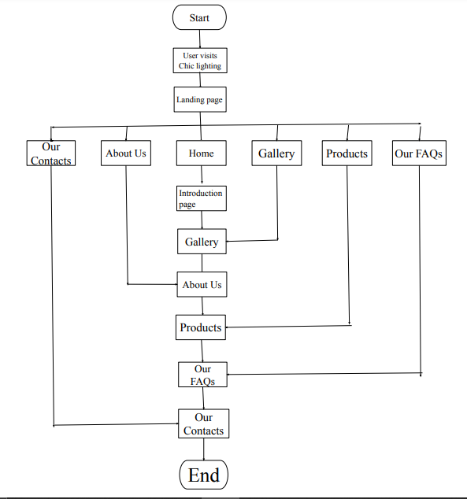

DATA FLOW DIAGRAM

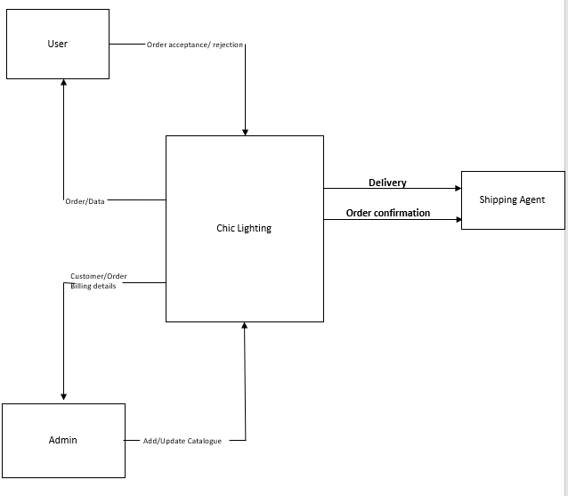

DATABASE PROCESS

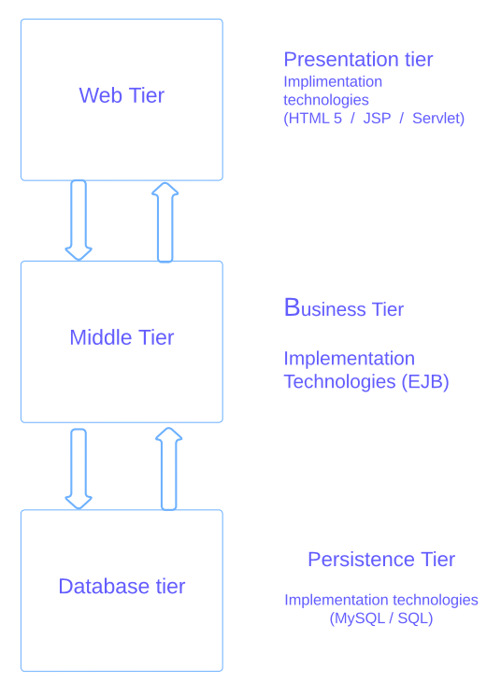

SCREEN SHOTS

LANDING PAGE

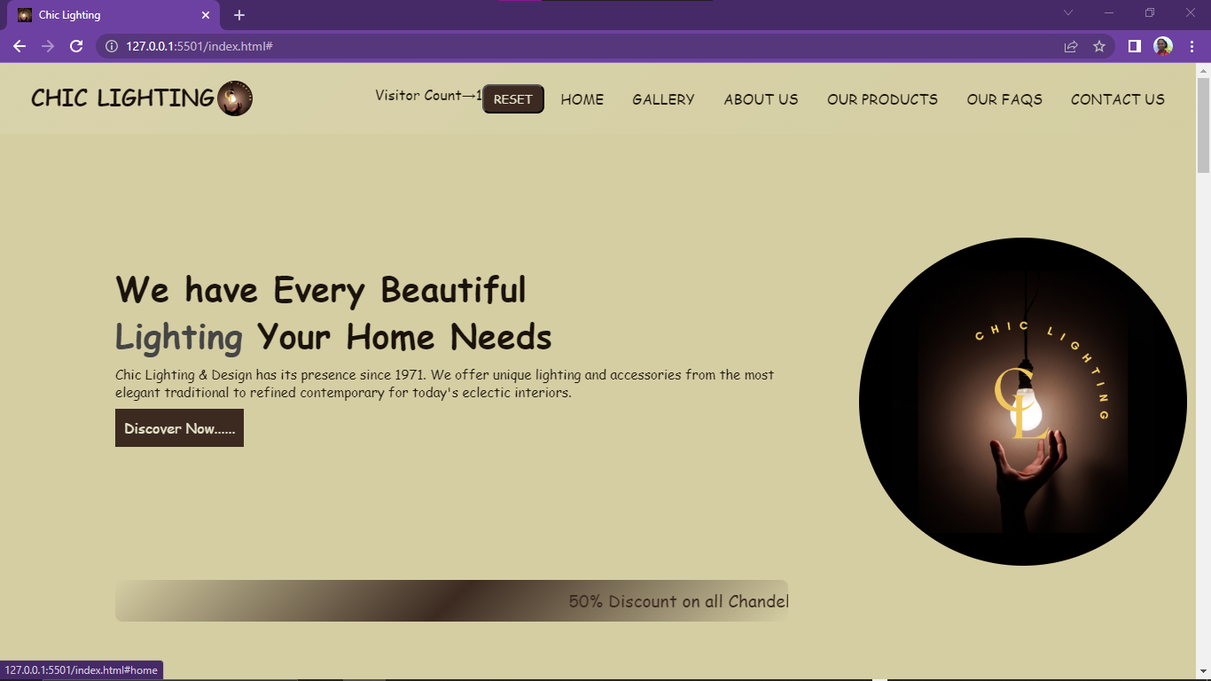

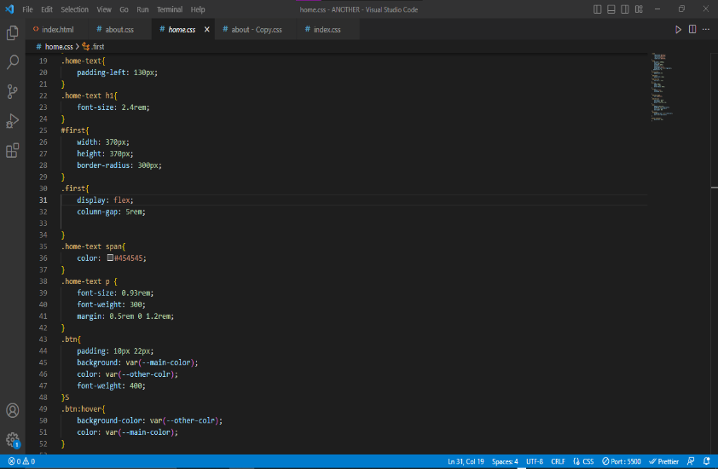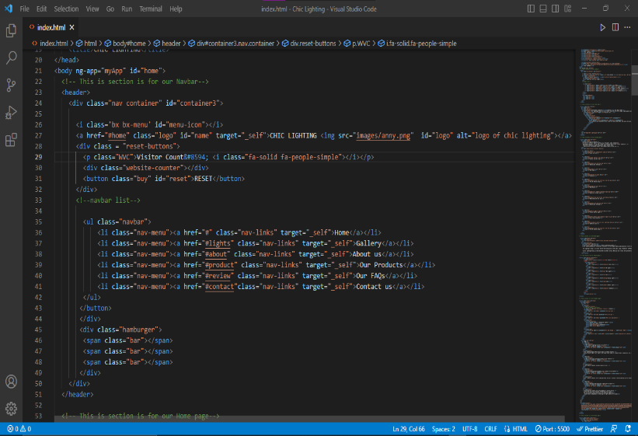

Gallery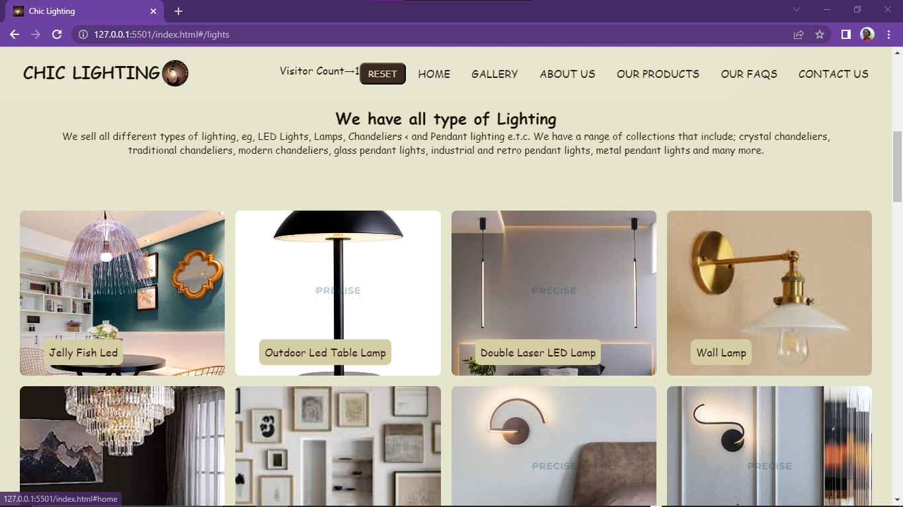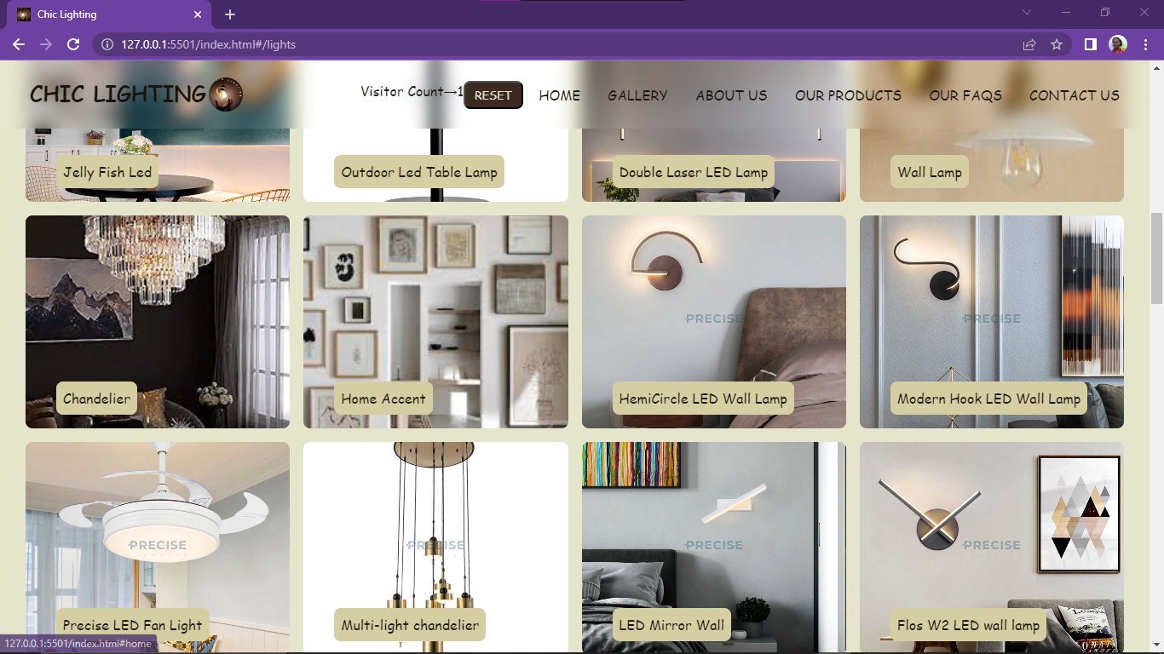

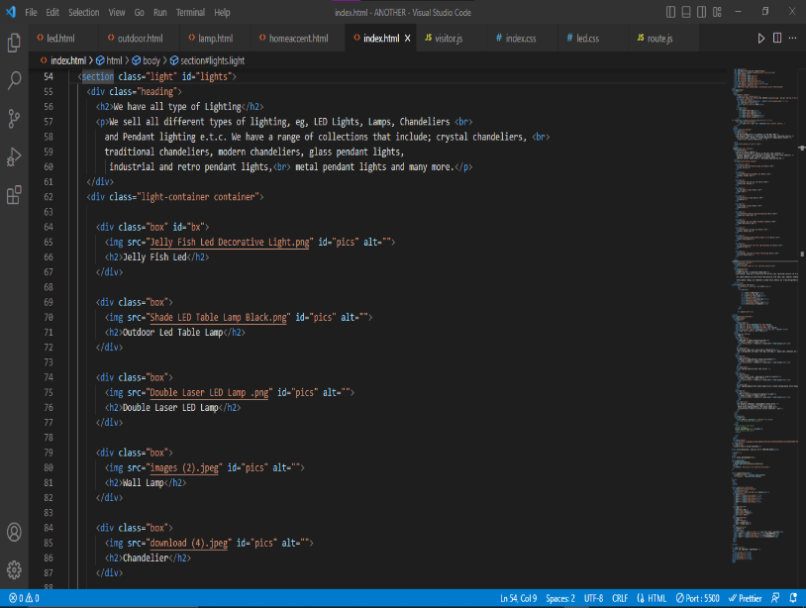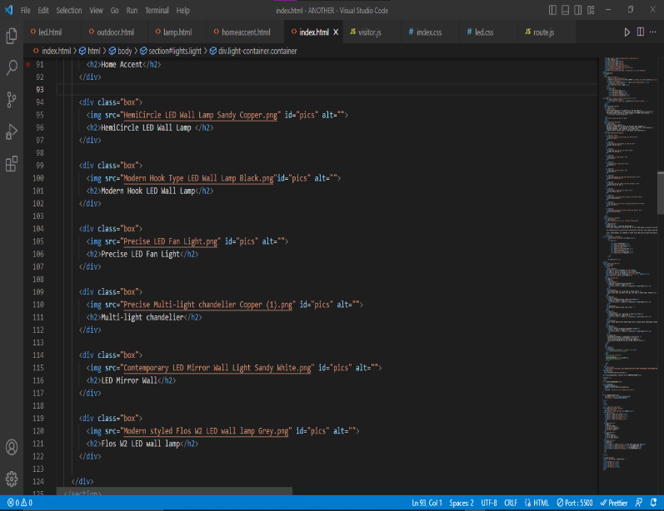

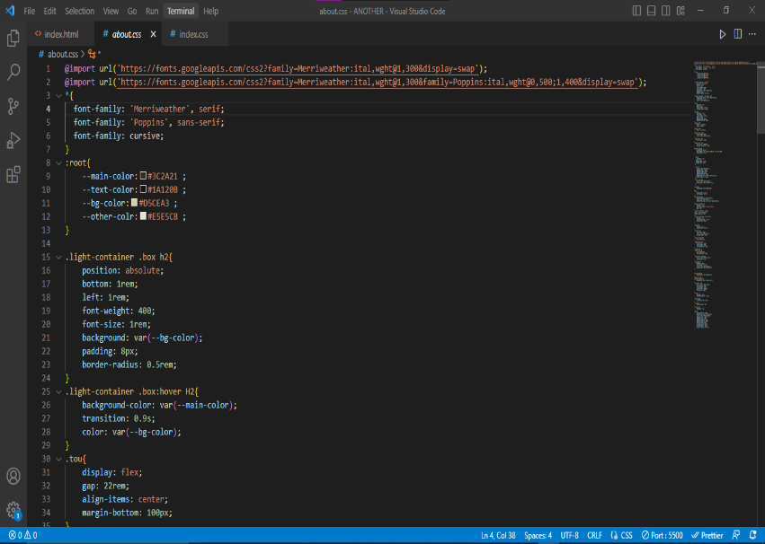

About Us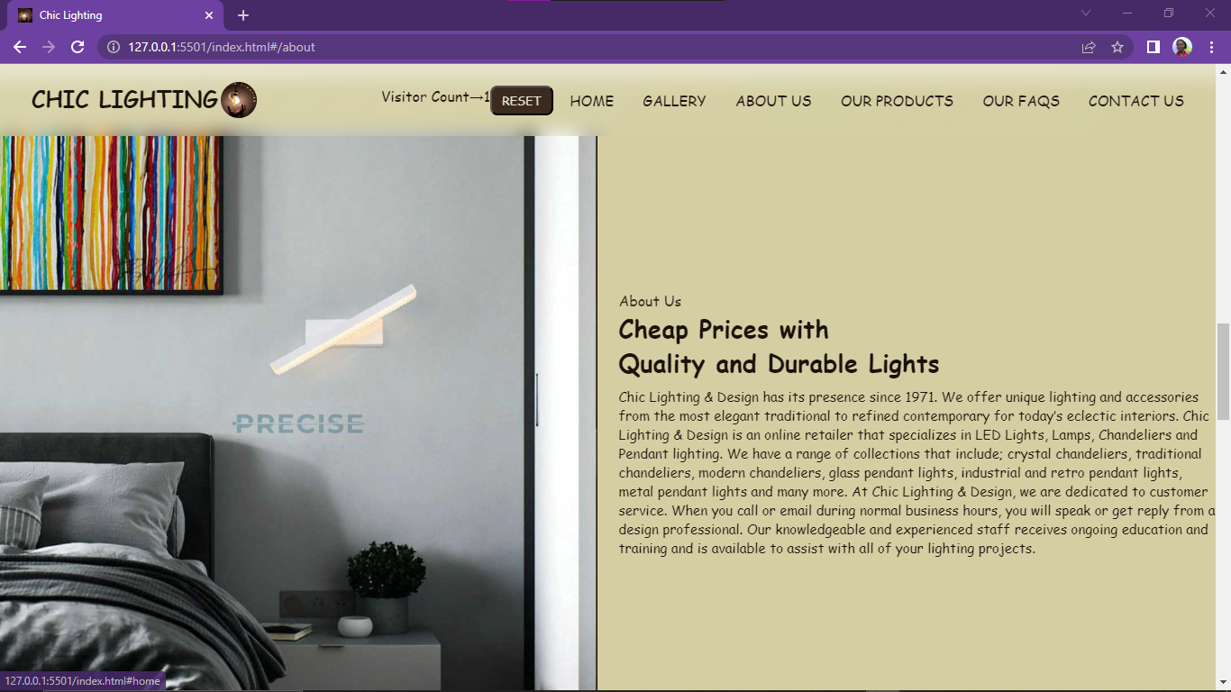

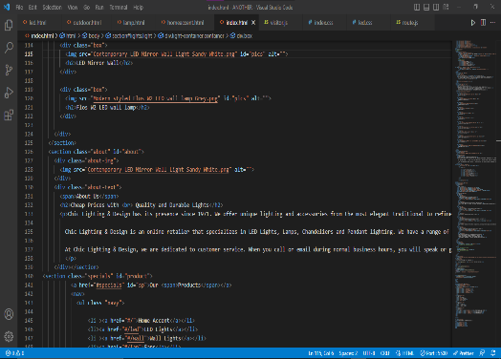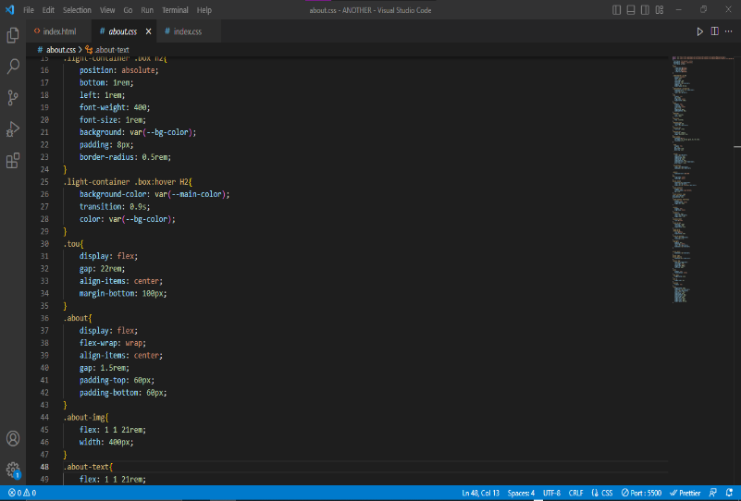

PRODUCTS SECTION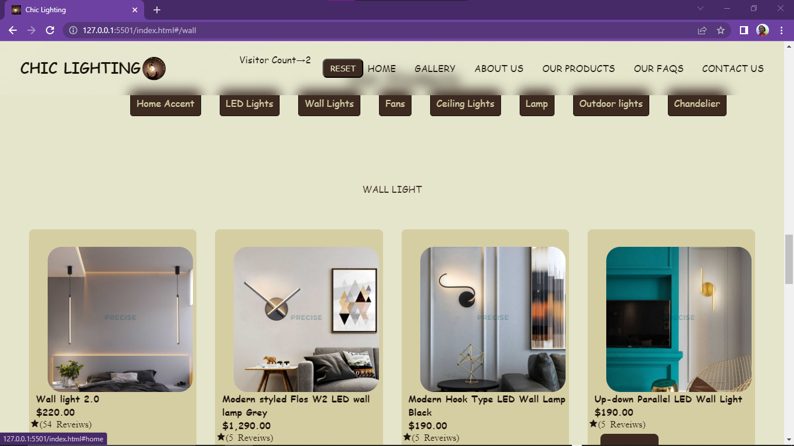

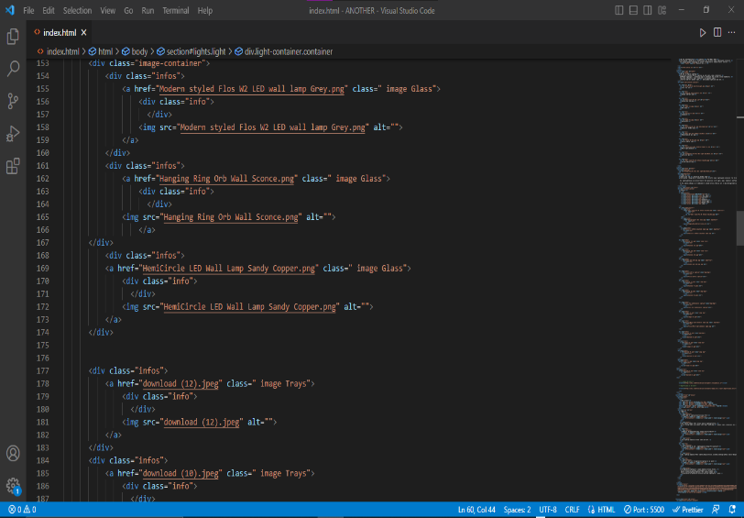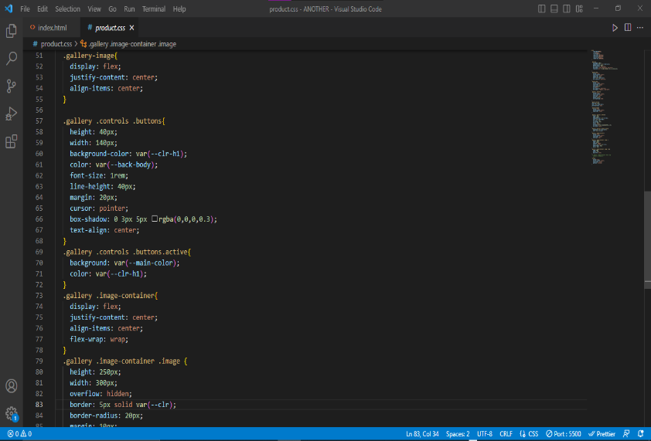

FAQs and FEEDBACK SECTION

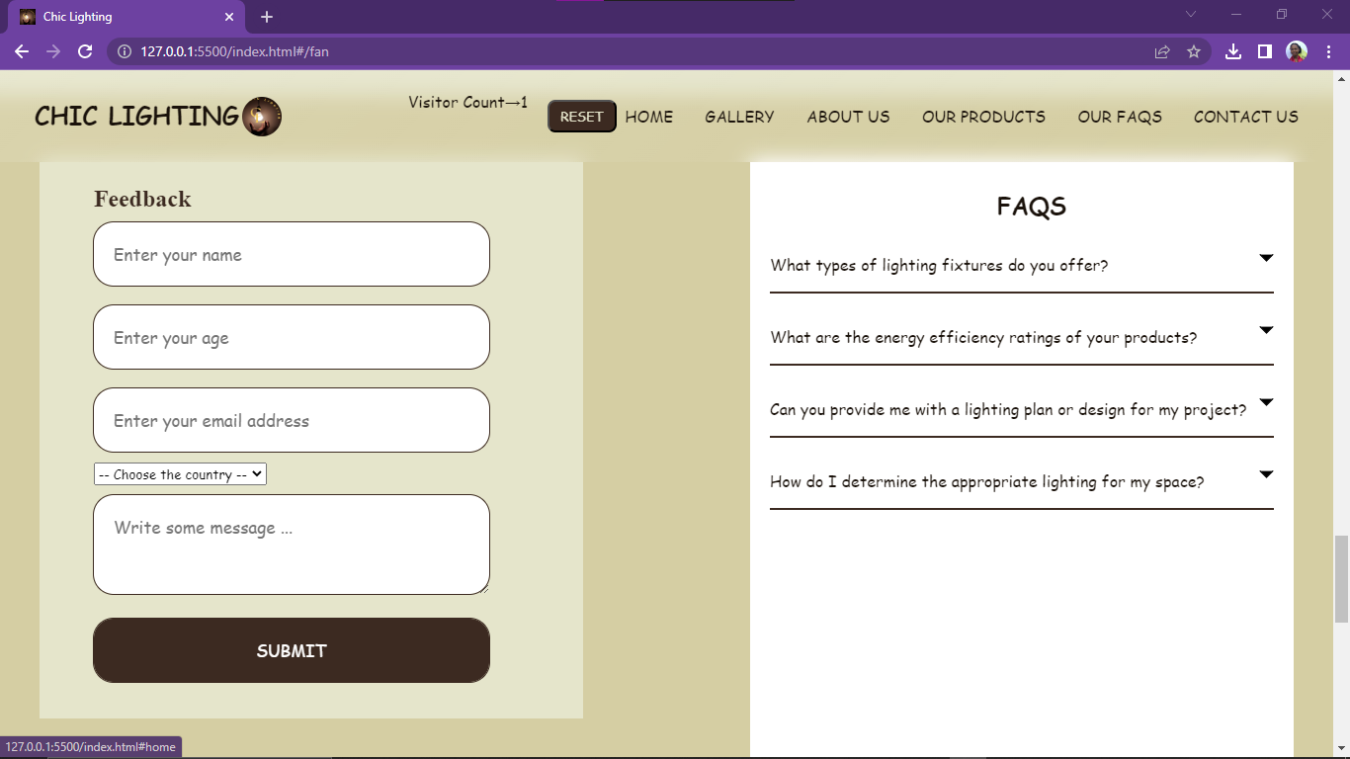

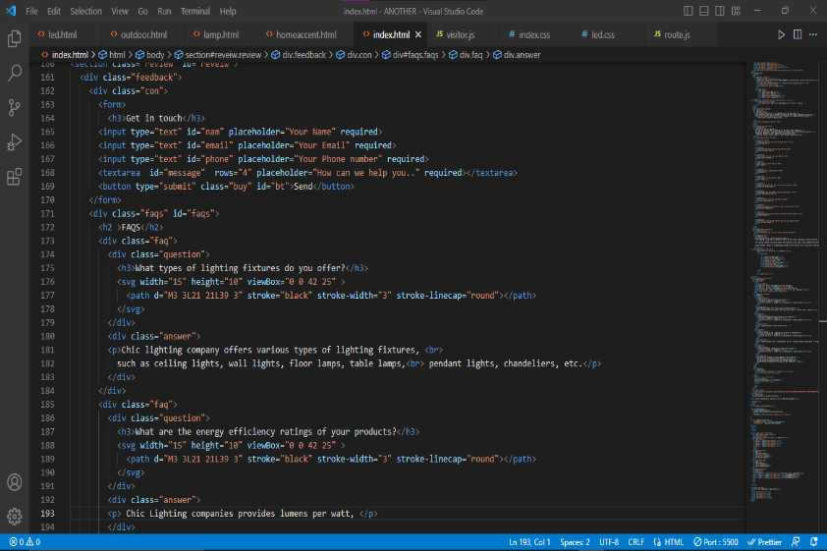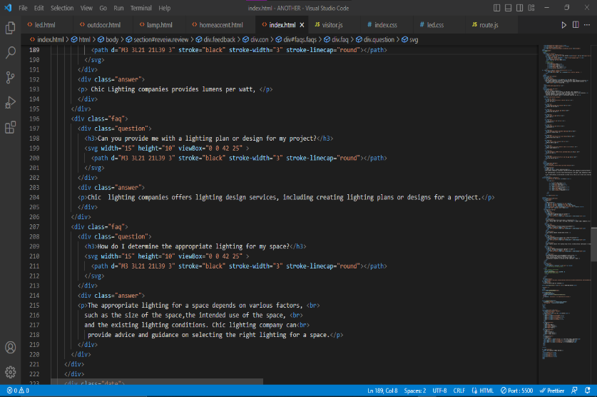

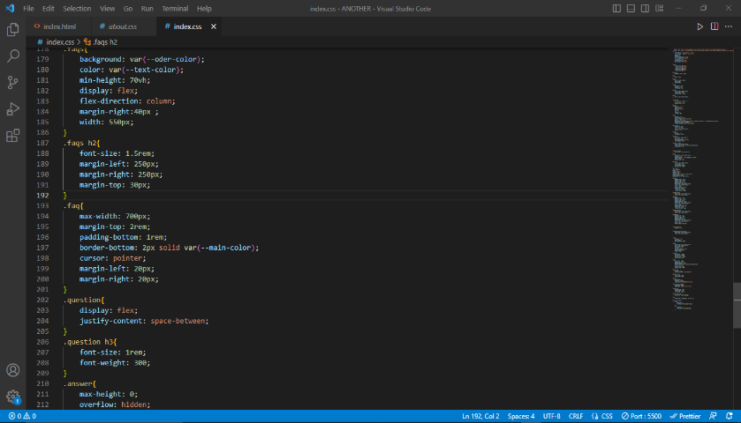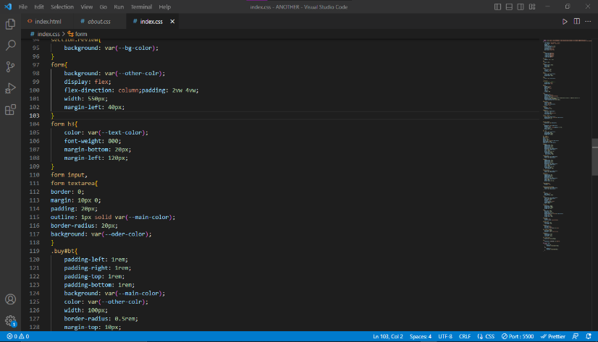

LOCATION and DATE SECTION

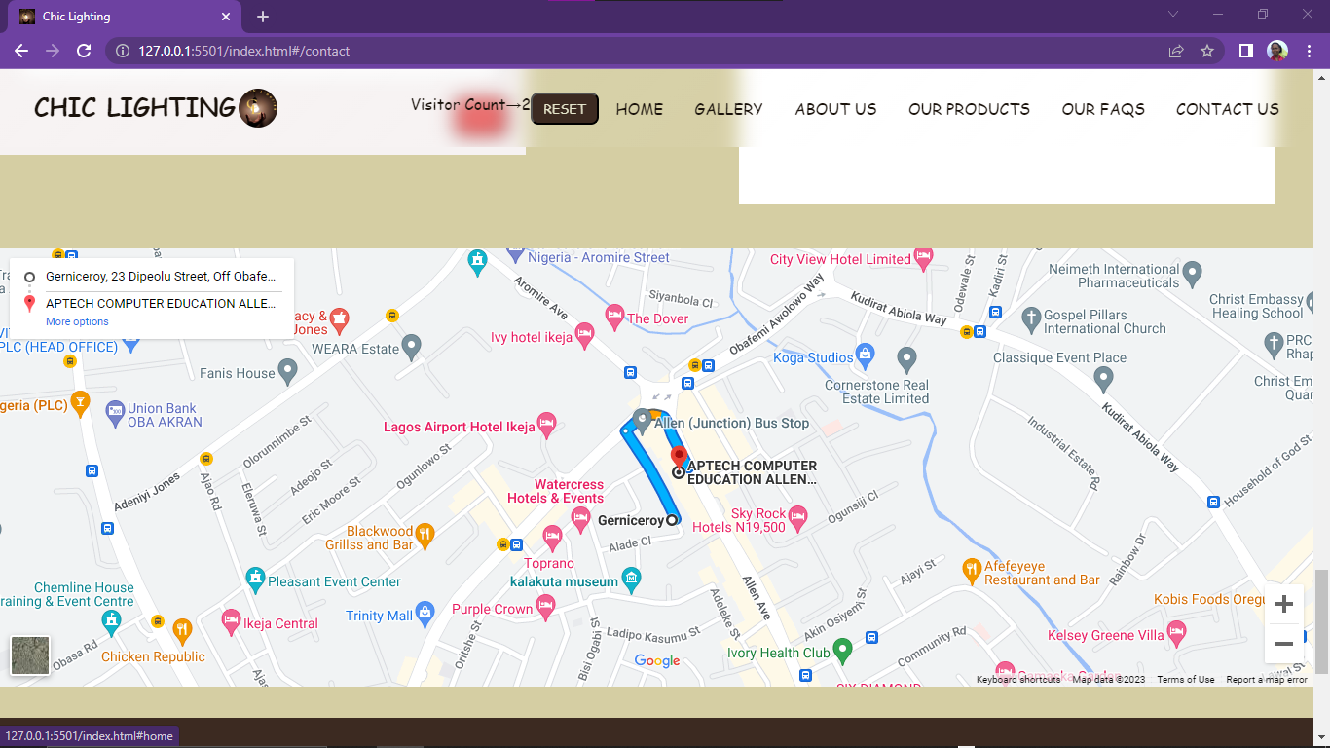

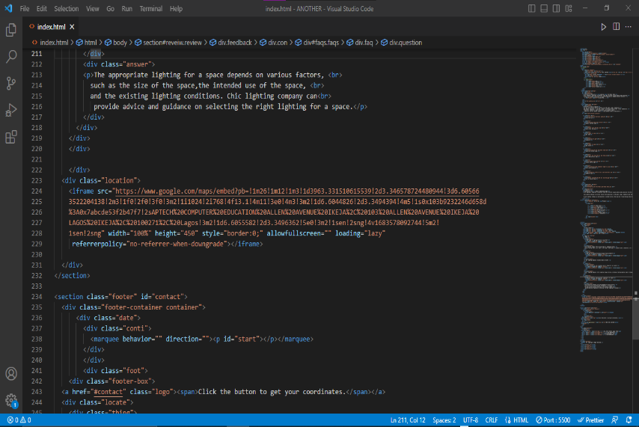

FOOTER SECTION

